Welcome to Lincoln High School!
A Tradition of Excellence for more than 50 years.
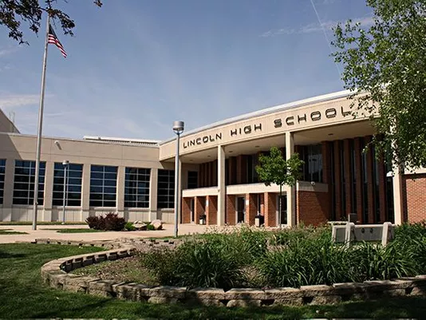
Lincoln High School Lincoln High School Administration
2900 S. Cliff Ave. Principal: Dr. Laura Raeder
Sioux Falls, SD 57105 Asst. Principal: Mr. Mitch Lynch
(605) 367-7990 Asst. Principal: Mrs. Danyelle Brown
www.sf.k12.sd.us Asst. Principal (Activities): Mr. David Maxwell

Lincoln High School Mission Statement
To educate and prepare each student to succeed in a changing world
Lincoln High School has been awarded numerous awards and recognized for several outstanding achievements over the years.
- US News and World Report Top 1000 High Schools 2008; 2009; 2010; 2011; 2012; 2013
- #1 School in the state of South Dakota; 2017-2018
- Donus D. Roberts Award in 2019
- Largest Marching Band in South Dakota for the last 40 years and in 2023 they placed 4th at the BOA Super Regional in St. Louis
- 53 students made All State Band in 2021 a record for any high school in the state
- 37 students made All State Orchestra in 2023 a record for the Sioux Falls School district
- In 2022-23 School year there were 157 President’s Award of Education Nominees
- The class of 2023 had 158 Regent Scholars
- #1 High School in the Sioux Falls School District; 2023-2024

Lincoln High School
Lincoln High School has a culture of high expectations and a tradition of exemplary student achievement. Lincoln High was opened in 1965. It is a comprehensive high school with an enrollment of approximately 2000 students. In 1979, the school was remodeled to make it accessible to the physically handicapped. It was again remodeled in 2000 to add more classrooms, a greenhouse, a little theater, and other improvements. In 2008, a new gymnasium was added to accommodate 2000 spectators greatly improving the ability to host large events. During 2017 Lincoln was named the Spanish Immersion High School in the Sioux Falls School district. The 2018-2019 school year brought extra support for our freshman students LHS implemented the Freshman Academy to help students transition to high school and the rigorous coursework. The school is on a traditional schedule with seven 50-minute class periods. Lincoln’s staff consists of 1 principal, 3 assistant principals, 6 counselors, 1 librarian, 108 teachers, plus a registrar, secretaries, and aides. Seventy three percent of the teaching faculty have at least a master’s degree or higher.

Students
Our Student body of approximately 1,900 students for 2022-23 had a graduating senior class of 443 students. We have a specific program for our student whose primary language is not English (English Language Learners program or ELL) and have approximately 115 students in this program. The Spanish Immersion program has 223 students currently enrolled.

Comprehensive Curriculum
Lincoln High has many courses in the twelve departments along with a full range of special education courses, alternative courses, and mentorships. We are committed to 21st Century skills such as analytical thinking, problem solving and collaborating. Our library has research capabilities that rival many colleges. In addition, Lincoln has the following features:
- Classrooms equipped with View Sonic Boards and voice enhancement technology
- All students are issued a Chromebook
- Online course registration for all students
- Parent and student portal for academics, attendance, and lunchbox accounts
- Outstanding weight training facility
- Wireless network capabilities throughout the school

Our courses are designed to meet abilities, interests, and needs of all students. Some of these specific areas include:
- Fine and Performing Arts: Many art courses offer a range of interest areas to include painting, photography, drawing, ceramics, AP Studio Art; and graphic design. Our performing arts department includes instrumental and choral music. We have four levels of band and ensemble jazz groups, and three levels of orchestra and four levels of chorus. All are age and/or skill grouped. In addition to these performing groups, we offer Music Theory and AP Music Theory.
- English: Emphasis is on writing, literature and speech with many selections including journalism, theater, debate, oral interp., film history, creative writing, AP Language/Composition, and AP Literature.
- Industrial/Vocational Technology: With the opening of the CTE Academy in the Sioux Falls School District, our students have the option of taking courses at the Academy, which are 2-hour block sections. These courses include CAD, media productions, auto technology, hospitality management, carpentry, health careers and more.
- World Language: Lincoln offers a full range of languages including four years of Spanish and AP Spanish, four years of French, four years of German, and four years of Latin along with AP Latin.
- Physical Education and Health: Our department offers a health class as well as several PE classes including weight training in our fully equipped weight room and a variety of lifetime sports activities.
- Science: We are proud to offer regular and accelerated levels of Chemistry, Physics, as well as AP Chemistry, AP Biology, AP Environmental Science and AP Physics. Other courses in this department range from physical science to astronomy/metrology, and anatomy/physiology.
- Math: All ability levels are served in the math department, from pre-algebra to geometry, pre-calculus; Algebra 2 and AP Statistics and AP Calculus. We also offer accelerated algebra, accelerated geometry classes and dual credit College Algebra taught on campus.
- Social Studies: Students may choose from a number of electives in this department as well as American History, government, economics, psychology, sociology, and geography. AP Government, AP World History, AP US History, AP World Geography, and AP Psychology are also offered.

Class Rank
Students graduating from Lincoln need to earn 22 credits to graduate. A full year class receives 1 unit of credit; a semester course receives .5 unit of credit. All courses taken during the school year and during summer school receive an A through F grade and these courses are included in the grade point average (GPA). Grade point averages and class rank are computed on all grades received in grades 9-12 and all courses receive equal weight. AP courses receive a weighted grade. Accelerated classes do not receive extra grade points.

Testing Profile (ACT) National Merit Scholars
The following is a history of our student’s ACT composite scores: The following is a history of scholarship finalists
Year No.Tested Composite Year No. Finalists
2016 268 24.1 2016 5 Finalists
2017 285 24.2 2017 5 Finalists
2018 298 23.7 2018 6 Finalists
2019 356 23.8 2019 13 Finalists
2020 269 23.5 2020 3 Finalists
2021 263 23.8 2021 11 Finalists
2022 318 24.1 2022 11 Finalists
2023 280 23.9 2023 12 Finalists

AP Scholar Students AP Scholar Awards
Year No. Students Year No. Awards
2016 139 2016 145
2017 165 2017 176
2018 183 2018 201
2019 182 2019 210
2020 163 2020 176
2021 207 2021 208
2022 251 2022 251
2023 240 2023 242

2020-2023 Grading Scale 2017-2019 Grading Scale
A: 90 – 100 A: 93 - 100
B: 80 – 90 B: 85 – 93
C: 70 – 80 C: 77 – 85
D: 60 – 70 D: 65 – 77
F: below 60 F: below 65

*During the 2019-20 school year, LHS transitioned to remote learning for all of 4th quarter.
*During the 2020-21 school year students had the option to do virtual learning throughout the school year.

